VMNL TEAM COACH
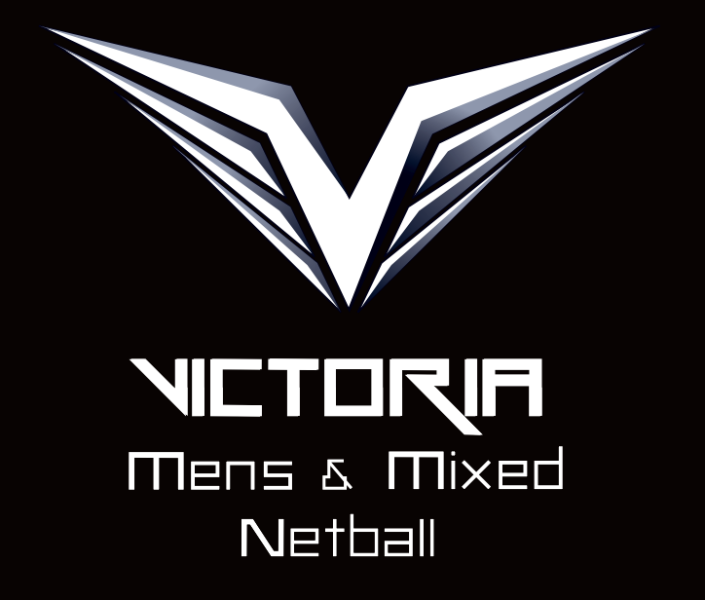
POSITION DESCRIPTION
_______________________________________________________________

The Coach of each state representative team is responsible for all matters pertaining to the following:

- Selection of players for this team
- Fitness
- Training program
- Skill development

The team coach is empowered to make decisions concerning these areas of responsibility prior to and during the championship.

Specifically, the team coach will be responsible for the following:

- Liaise with the Team Manager to ensure all activities are carried out in preparation for the training program i.e. equipment, venues, opposition, etc.
- Attend all team training sessions or ensure an alternative arrangement is in place for a suitable coaching substitute
- Bring to the attention of the Team Manager any matter which may inhibit the team’s performance (including enquiries from the players)
- Implementing and making decisions regarding match tactics during a game
- Participate in the State Team selections as a State Team Selector
- Perform the functions of the Team Manager when they are not present at training sessions
- Where requested participate in the development of Men’s and Mixed Netball via clinics or other channels as advised by the VMNL committee.
- Submit a written report at the completion of the championship to the VMNL committee
- Provide guidance to Team Manager in regards to team dietary needs where required
- Adhere to the codes of conduct for VMNL and AMMNA
- Participate in all VMNL arranged specialised training/fitness sessions.

