VMNL TEAM MANAGER
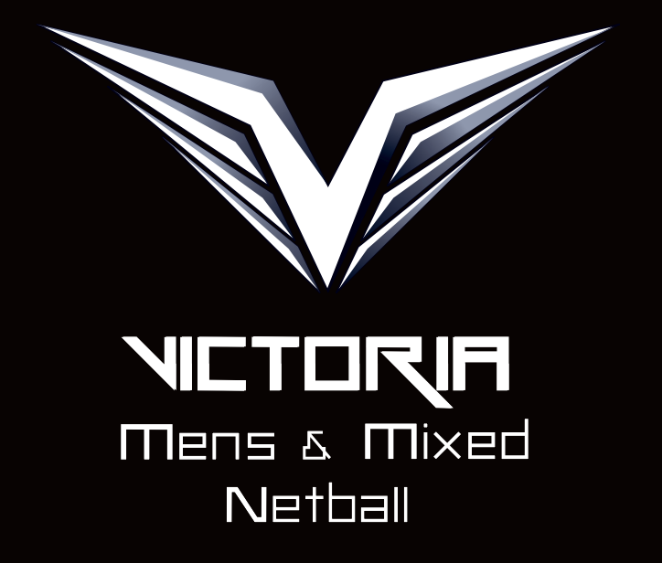
POSITION DESCRIPTION
_______________________________________________________________

The Manager of each Victorian team is considered a senior member of the team and may be responsible for making decisions regarding the team’s welfare. They will also be required to adhere to the current code of conduct.

Specifically, they will be responsible for the following:

- Updating names, addresses, telephone numbers and all relevant netball information for each player and official travelling with that team. This is to occur at the point of notification to the TM and reported via email to VMNL immediately.
- Team attendance report to be taken at each training session and reported to VMNL weekly.
- Liaise with the Team Coach to ensure all responsibilities are carried out in preparation for the training program
i.e. Equipment, venues, opposition, etc.
- Liaise with the VMNL Umpires Coordinator to ensure that umpires are available when required
- Attend all training sessions and all team functions
- Send a weekly report of players training attendance/or not to the committee
- Ensure all VMNL property (balls, etc) is properly accounted for and returned to the VMNL after the Championships have concluded
- Collect all moneys required and maintain an accurate accounting of such moneys using the provided VMNL Log Book.
- Return Accounting log book at the conclusion of the championship.
- Liaise with the VMNL Treasurer to ensure all representatives are up to date with payments
- Follow up and prompt all participants for all payments required
- Actively participate in the fundraising activities for that team
- Ensure at all times, the team behaviour is appropriate in accordance with the VMNL and AMMNA Codes of Conduct and meets all dress code requirements
- Report any breaches of the Code of Conduct or breaches of VMNL and AMMNA policies to the appropriate person immediately where convenient.
- Resolve any team issue or matter which may inhibit the team’s performance
- During the championships:
- Wash the playing uniforms
- Prepare meals appropriately to dietary needs
- Take direction and perform duties as requested and directed by the team coach
- Ensure appropriate transport arrangements are made for the duration
- Being aware of any players medical requirements
- Escalate any issue which may arise during the commencement of the training period through to the completion of the championship
- Maintain an appropriate relationship with the team coach, working together to support the teams needs
- Develop and provide support to other team managers where required
- Submit a written report at the completion of the championships to the VMNL committee

