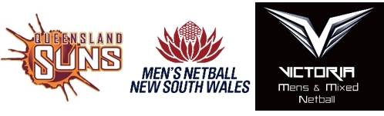

AUSTRALIAN MEN’S & MIXED NETBALL ASSOCIATION
Code of Conduct

We have a great sport that we all love, either as a Player, Coach, Manager, Technical Official or Administrator. We want to be seen as an elite sport, and it is important we act in manner acceptable to family and friends, work colleagues or to the general public. We must be seen as an example of an elite sport to encourage parents to support their children to play the game and strive for ongoing improvement through the development pathways.

We must encourage involvement and embrace diversity. It makes the sport richer and stronger and increases the level of participation and improves the overall standard.

I agree to the following:

- Professionalism – to act professionally during the course of my involvement with the Australian Men’s and Mixed Netball Association Inc (the Association) and ensure my actions do not compromise the reputation of the Association or bring its standing into disrepute.
- Harassment – to refrain from any behaviour that is offensive, insulting, humiliating, bullying, intimidating or that creates a hostile environment amongst fellow officials, players and any others involved in netball.
- Sexual harassment - to refrain from sexual advances, making comments that a reasonable person would find offensive, humiliating or intimidating.
- Social media and electronic communication – to refrain from making comments or publishing explicit photographs, or photographs of a person without their permission on social media and/or via electronic communication transmissions that are illegal, offensive, insulting, humiliating, bullying, intimidating or that create a hostile environment amongst fellow officials, players and any others involved in netball.
- Anti-drug and alcohol policy – all players and officials must be aware of and follow the guidelines of the Australian Sports Drug Agency.
- I have not been convicted of any criminal offence in relation to a child or young person, nor have I been convicted of a serious criminal offence and do not have a current Apprehended Violence Order or similar restraining order against me.
I, _________________________________________________ Date of birth ____/____/____

Email: ___________________________________________ Mobile: ___________________

Acknowledge and agree to the above Code of Conduct and acknowledge and agree that should I breach any provision of the Code of Conduct, I can be immediately suspended or permanently excluded from participation in the Australian Men’s and Mixed Netball Association Inc.

_________________________________ ______________________________ ____/____/____
Name (print) Signature Date
Note a Parent/Guardian must sign on behalf of player or official if aged under 18.

