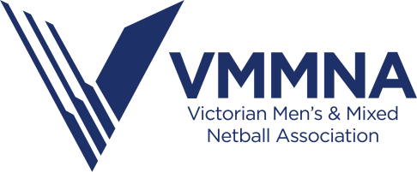

VMMNA Position Description – Team Manager
Policy Title | Position Description
Reports to | Tour Manager, VMMNA Committee
Date Written | 30/6/2020

About the Role
The primary purpose of this position is to provide support and assistance to the coach in order to allow for them to be able to deliver a high quality netball coaching program to athletes within the VMMNA state program. The Team Manager of each State team is considered a senior member of the team and may be responsible for making decisions regarding the team’s welfare. They will also be required to adhere to the current code of conduct.

Key responsibilities
Team Training | - Team attendance report to be taken at each training session and reported to the Tour Manager upon request  - Liaise with the Team Coach to ensure all responsibilities are carried out in preparation for the training program  - Attend all training sessions and all team functions  - Liaise with the VMMNA Umpire Coordinator to ensure that umpires are available at training when required  - Ensure all VMMNA property/equipment is properly accounted for and returned to VMMNA upon conclusion of the AMMNA Championships  - Resolve any team issues or matter which may inhibit team performance  - Assist Coach when requested
Management & Reporting | - Updating names, addresses, telephone numbers and all relevant netball information for each player and official travelling with that team. This is to occur at the point of notification to the TM and reported via email to the Tour Manager immediately  - Collect all moneys required for team kitty and maintain an accurate accounting of such moneys using the provided VMMNA Log Book  - Return accounting log book at the conclusion of the AMMNA Championships  - Liaise with the VMMNA Treasurer to ensure all representatives are up to date with payments  - Follow up and prompt all participants for all payments required  - Actively participant in fundraising activities for the team  - Ensure at all times, the team behaviour is appropriate in accordance with the VMMNA and AMMNA Codes of Conduct and meets all dress code requirements  - Report any breaches of the Code of Conduct or breaches of the VMMNA/AMMNA policies to the appropriate person immediately where convenient  - Develop and provide support to other team managers where required  - Submit a written report at the completion of the AMMNA Championships to the VMMNA Committee
AMMNA Championships | - Wash playing uniforms (Junior teams may need other items washed)  - Prepare meals appropriately to dietary needs  - Take direction and perform duties requested and directed by the team coach  - Ensure appropriate transport arrangements are made for the duration  - Be aware of any medical requirements of players  - Escalate any issues which may arise during the commencement of the training period through to the completion of the championship  - Maintain an appropriate relationship with the team coach, working together to support the teams needs  - Assist the coach during matches as requested

Personnel Specification
Skills & Competencies | Essential  - Highly developed planning and organisation skills  - Excellent communication and interpersonal skills  - Ability to manage a group of participants effectively  - Ability to work independently and as part of a team  - Ability to meet the duties, attendance and report requirements as per this agreement
Other | - All candidates applying for this position must hold a current driver’s license  - Evidence of a valid Working With Children Check clearance must be provided prior to commencement of role

Enquires
Please contact Sonya Febbo (Tour Manager) via email with any queries
tourmanager@vmmna.org

Applications close at 5PM on 31st July 2020

